™

™

Client Bulletin

June 2023 | Volume 12, Issue 12.1
This bulletin lists Sights for Hope’s life skills education programs, peer support groups, and activities for its clients in the Lehigh Valley and Monroe County.

Large-Print Pullout Calendars
- Lehigh Valley: Pages 9 and 12
- Monroe: Pages 10-11
Designed to be pulled apart and displayed

Lehigh Valley Services Center
845 West Wyoming St., Allentown, PA 18103

610.433.6018
Monroe Services Center
4215 Manor Drive, Stroudsburg, PA 18360
570.992.7787

Choose How You Receive Your Client Bulletin
You can choose how you receive this bulletin. Your choices are listed below.

- Receive it in the postal mail in large print
- Receive it in the postal mail in extra-large print
- Receive it in the postal mail as a braille document
- Receive it as an audio file on a USB drive
- Receive it as an email message
- Download it in Word or PDF formats at

SightsforHope.org/Bulletins
- Listen to it online at SightsforHope.org/Bulletins

Please contact your caseworker if you want to change the way you receive the bulletin.

How to Schedule Transportation
Call one of our transport coordinators Monday-Friday from 8:30 a.m.-4:30 p.m. to schedule a ride.
Lehigh Valley
Brian Schell, 610.433.6018, Ext. 226
Monroe County
Lisa Metcalf, 570.992.7787, Ext. 224

- What’s Exciting

Bethlehem Fine Arts Commission Offers Opportunity for Sculptors with Visual Impairments
The Bethlehem Fine Arts Commission is in search of a sculptor who lives with a visual impairment to be
part of a juried art exhibit in the Bethlehem Town Hall Rotunda Gallery from
September 30 to
November 4, 2024.

Interested sculptors should send photos of 3-4 samples that represent their style to James DePietro at jadepietro@rcn.com. Those sample works do not need to be used in the exhibition.

The Bethlehem Fine Arts Commission will be in touch with the sculptor whose work is selected.

Payments for Beacon Lodge Transportation Due July 5
Payments for transportation to the Pennsylvania Lions Beacon Lodge camp is due Wednesday, July 5. The cost is $80, payable to Springfield Lions Club.

Checks should be sent to John Anderson, 1829 East Madison St., Philadelphia, PA 19132. Clients also can call 215.410.8524 for additional information.

The bus will depart from the former Kmart store on Tilghman Street in Allentown on Saturday, July 15 and return on Tuesday, July 25.

Musicians Wanted for Client Band
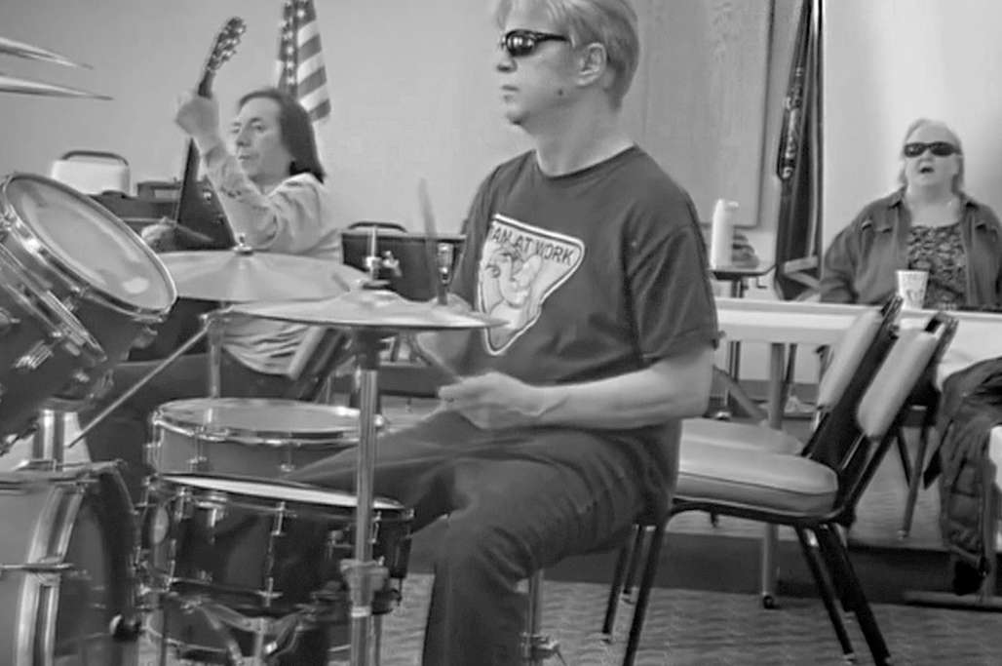The Sights for Hope client band is looking for a drummer and a bass player. Interested clients should call Rita Lang at 610.433.6018, Ext. 225.

Life Skills Education Programs

Tech Talks
  - Who Can Participate: All clients
  - Dates and Times: Thursdays, June 1, 8, 15, 22, and

29, 2-3:30 p.m.
  - Virtual Connections: Go to SightsforHope.org/Events

Beginner Braille in Monroe
  - Who Can Participate: All enrolled clients
  - Dates and Times: Tuesday, June 20, 10:30 a.m.- 1 p.m.
  - Location: Monroe Services Center
  - Registration: Lisa Metcalf at 570.992.7787, Ext. 224
  - Who Can Schedule Transportation: Monroe clients

iOS Device Workshop
Learn about the iPhone and iPad. Please bring a lunch or money to order.
  - Who Can Participate: All clients
  - Date and Time: Wednesday, June 21, 11 a.m.- 1 p.m.
  - Location: Lehigh Valley Services Center
  - Registration: Rita Lang at 610.433.6018, Ext. 225
  - Who Can Schedule Transportation: Not available
  - Virtual Connections: Go to SightsforHope.org/Events

Peer Support Groups

Lehigh Valley Client Group
Facilitated by James Van Horn.
  - Who Can Participate: Lehigh Valley clients
  - Date and Time: Thursday, June 1, 10-11:30 a.m.
  - Location: Lehigh Valley Services Center
  - Registration: Rita Lang at 610.433.6018, Ext. 225
  - Who Can Schedule Transportation: Lehigh Valley clients
  - Virtual Connections: Go to SightsforHope.org/Events

Monroe Client Group
Facilitated by James Van Horn.
  - Who Can Participate: Monroe clients
  - Date and Time: Monday, June 5, 10-11:30 a.m.
  - Location: Monroe Services Center
  - Registration: Lisa Metcalf at 570.992.7787, Ext. 224
  - Who Can Schedule Transportation: Monroe clients
  - Virtual Connections: Go to SightsforHope.org/Events

Peer Support Groups

Women’s Client Group
  - Who Can Participate: All female clients
  - Date and Time: Tuesday, June 13, 10-11 a.m.
  - Location: Lehigh Valley Services Center
  - Registration: Rita Lang at 610.433.6018, Ext. 225
  - Who Can Schedule Transportation: Not available
  - Virtual Connections: Go to SightsforHope.org/Events

Activities

Mall Walks
  - Who Can Participate: All clients
  - Dates and Times: Wednesdays, June 7, 14, 21, and 28,

9-10:30 a.m.
  - Location: South Mall, 3300 Lehigh St., Allentown, PA
  - Who Can Schedule Transportation: Lehigh Valley clients

Activities

Visit to the Marshall Steam Museum in Northern Delaware
The Marshall Steam Museum at Auburn Heights offers visitors a chance to step back in time and experience life at the dawn of the automotive age. The museum features the world’s largest operating collection of Stanley steam cars; a 1916 early electric car; a Ford Model T; two 1930s Packards; and the Auburn Valley Railroad, with its
1/8th-sized steam and diesel trains that circle the property.

Experience an audio-described tour with hands-on components of the permanent collection and a special fashion collection.

  - Who Can Participate: Lehigh Valley clients
  - Date and Time: Tuesday, June 6, 11 a.m.-2 p.m.

Location: Marshall Steam Museum at Auburn Heights, 3000 Creek Road, Yorklyn, DE
  - Who Can Schedule Transportation: Lehigh Valley clients

- Descriptions Continue on Page 13

June 2023

Lehigh Valley Client Calendar
Thursday | Friday | Saturday
1  Lehigh Vly Group  10-11:30 | 2 | 3
8 | 9 | 10  GLVNFB Mtg 10-12
15  Bingo Bash 10:30-1 | 16 | 17  LVCB Mtg 10-1
22 | 23 | 24
29Visionaries  10:30-12:30  LV Lions 12:30-1:30 | 30

Want to Do More?
Most Monroe activities also are open to Lehigh Valley clients who can arrange their own rides.
Check out the descriptions for details.

- Weekly Services Mall Walks
June 7, 14,
21, and 28,
9-10:30

Tech Talks
June 1, 8, 15,
22, and 29,
2-3:30

June 2023
Monroe Client Calendar

Sunday | Monday | Tuesday | Wednesday
4 | 5  Monroe Group 10-11:30 | 6 | 7
11 | 12 | 13 | 14
18 | 19 | 20  Braille 10:30-1 | 21
25 | 26  Musicians 11-1 | 27 | 28

June 2023

Monroe Client Calendar
Thursday | Friday | Saturday
1 | 2 | 3
8 | 9 | 10
15 | 16  Mini Golf 11-1 | 17
22  Minsi Trail Walk  11-1 | 23 | 24
29 | 30 NuVisions  10:30-12  Monroe Lions 1-2

Want to Do More?
Most Lehigh Valley activities also are open to Monroe clients who can arrange their own rides.
Check out the descriptions for details.

Weekly Services
Tech Talks
June 1, 8, 15,
22, and 29,
2-3:30

June 2023
Lehigh Valley Client Calendar

Sunday | Monday | Tuesday | Wednesday
4 | 5 | 6  Stream Museum 11-2 | 7
11 | 12 | 13 Women’s  Group  10-11  Crafters 11-1 | 14
18 | 19 | 20  Outdoor Walk  11-1 | 21  iOS Devices 11-1
25 | 26 Dominoes  10-11:30  Musicians 11-1 | 27 | 28

Activities

Crafters Corner Activity
    - Who Can Participate: All clients
    - Date and Time: Tuesday, June 13, 11 a.m.-1 p.m.
    - Location: Lehigh Valley Services Center
    - Registration: Rita Lang at 610.433.6018, Ext. 225
    - Who Can Schedule Transportation: Not available

Annual Bingo Bash
Enjoy our pizza luncheon and try your luck at winning items that make daily life with low vision easier.
      - Who Can Participate: All clients
      - Date and Time: Thursday, June 15, 10:30 a.m.-1 p.m.
      - Location: Lehigh Valley Services Center
      - Who Can Schedule Transportation: Lehigh Valley clients

Miniature Golf
Enjoy a round of miniature golf at the Snydersville Golf Range. The cost is $5.00 per person.
      - Who Can Participate: All clients
      - Date and Time: Friday, June 16, 11 a.m.-1 p.m.
      - Location: Snydersville Golf Range,

125 Meadowbrook Lane, Stroudsburg, PA
      - Who Can Schedule Transportation: Monroe clients

Activities

Outdoor Walk at Northampton Canal Park Explore the Canal Park Walking Trail in Northampton, PA. Please wear comfortable shoes and bring a lunch.
    - Who Can Participate: All clients
    - Date and Time: Tuesday, June 20, 11 a.m.-1 p.m.

Location: Northampton Canal Park, 1417 Canal St., Northampton, PA
    - Who Can Schedule Transportation: Lehigh Valley clients

Outdoor Walk on the Minsi Trail
Use all your senses to explore the outdoors at Lake Minsi.
Please bring a bagged lunch.
    - Who Can Participate: All clients
    - Date and Time: Thursday, June 22, 11 a.m.-1 p.m.

Location: Lake Minsi Drive, Upper Mount Bethel, PA
    - Who Can Schedule Transportation: Monroe clients

Activities

Dominoes for Spanish-Speaking Clients
    - Who Can Participate: All Spanish-speaking clients
    - Date and Time: Monday, June 26, 10-11:30 a.m.
    - Location: Lehigh Valley Services Center
    - Registration: Stephanie Guillen at 610.433.6018, Ext. 246
    - Who Can Schedule Transportation: Lehigh Valley clients

Musician Jam Session
    - Who Can Participate: All clients who are musicians and/or vocalists
    - Date and Time: Monday, June 26, 11 a.m.-1 p.m.
    - Location: Monroe Services Center
    - Who Can Schedule Transportation: Lehigh Valley and Monroe clients

Activities

Visionaries Client Group Activity
Take part in the last of a six-part series on mindfulness. This activity is organized by the Visionaries client group but is open to all Lehigh Valley clients. Please note that the Lehigh Valley Sights for Hope Lions Club will meet after this activity.
    - Who Can Participate: All Lehigh Valley clients
    - Date and Time: Thursday, June 29, 10:30 a.m.- 12:30 p.m.
    - Location: Lehigh Valley Services Center
    - Who Can Schedule Transportation: Lehigh Valley clients

NuVisions Client Group Activity
This activity is organized by the NuVisions client group but is open to all Monroe clients.
    - Who Can Participate: All Monroe clients
    - Date and Time: Friday, June 30, 10:30 a.m.-12 p.m.
    - Location: Monroe Services Center
    - Registration: Jennifer Pandolfo at 570.992.7787, Ext. 223
    - Who Can Schedule Transportation: Monroe clients

Meetings

LV Sights for Hope Lions Club Meeting The Lehigh Valley Sights for Hope Lions Club will hold its monthly meeting. All clients who live in Lehigh and Northampton counties are welcome.
    - Who Can Participate: All Lehigh Valley clients
    - Date and Time: Thursday, June 29, 12:30-1:30 p.m.
    - Location: Lehigh Valley Services Center
    - Additional Details: SightsforHope.org/LVLionsClub

Monroe Sights for Hope Lions Club Meeting The Monroe Sights for Hope Lions Club will hold its monthly meeting. All clients who live in Monroe County are welcome. Participants are encouraged to bring a lunch or
money to order.
    - Who Can Participate: All Monroe clients
    - Date and Time: Friday, June 30, 1-2 p.m.
    - Location: Monroe Services Center
    - Registration: Jennifer Pandolfo, 570.992.7787, Ext. 222
    - Who Can Schedule Transportation: Monroe clients
    - Additional Details: SightsforHope.org/MonroeLionsClub

Meetings

Greater LV Chapter - National Federation of the Blind (GLVNFB) Meeting
    - Date and Time: Saturday, June 10, 10 a.m.-12 p.m.

Location: Denny’s Restaurant, 1871 Catasauqua Road, Allentown, PA
    - Additional Details: Call Kirk Hunger at 484.239.0741

LV Council of the Blind (LVCB) Meeting
Please bring a lunch or money to order.
    - Who Can Participate: LVCB members
    - Date and Time: Saturday, June 17, 10 a.m.-1 p.m.
    - Location: Lehigh Valley Services Center
    - Additional Details: Write to LVCB1993@gmail.com

Lehigh Valley Staff Directory

Main Number 610.433.6018
Dennis Zehner, Executive Director and CEO, Ext. 241 Jennifer Pandolfo, Associate Director/Dir. of Services, Ext. 223 Deirdre Federico Snyder, Director of Advancement, Ext. 244 Nancy Cobb, Operations Manager, Ext. 242
Rita Lang, Client Activities Manager, Ext. 225 Enid Cruz, Client Services Assistant, Ext. 240
Dianne Michels, Vision Rehabilitation Therapist, Ext. 230 Stephanie Guillen, Client Caseworker, Ext. 246
Erin Hahn, Client Caseworker, Ext. 231 Erica Vibert, Client Caseworker, Ext. 227
Kim Williams, Low Vision Care Coordinator, Ext. 224 Brian Schell, Transport Coordinator, Ext. 226 Colleen Rountree, Prevention Specialist, Ext. 245

Monroe Staff Directory

Main Number 570.992.7787
Jennifer Pandolfo, Associate Director/Dir. of Services, Ext. 222 Yvette Quintero, Lead Client Caseworker, Ext. 221
Melinda Weston, Client Caseworker, Ext. 228 Cheryl Miller, Low Vision Care Coordinator, Ext. 229 Lisa Metcalf, Transport Coordinator, Ext. 224 Angela Hill, Prevention Specialist, Ext. 223

FREE MATTER FOR THE BLIND OR PHYSICALLY HANDICAPPED
Post Manual Part 138

Client Bulletin

This bulletin is a public service provided in part by

DESIGN | PRINT | FINISH | MAIL

This publication © 2023 Sights for Hope

