™

™

Client Bulletin

May 2023 | Volume 12, Issue 11.1
This bulletin lists Sights for Hope’s life skills education programs, peer support groups, and activities for its clients in the Lehigh Valley and Monroe County.

Large-Print Pullout Calendars
- Lehigh Valley: Pages 9 and 12
- Monroe: Pages 10-11
Designed to be pulled apart and displayed

Lehigh Valley Services Center
845 West Wyoming St., Allentown, PA 18103

610.433.6018
Monroe Services Center
4215 Manor Drive, Stroudsburg, PA 18360
570.992.7787

Choose How You Receive Your Client Bulletin
You can choose how you receive this bulletin. Your choices are listed below.

- Receive it in the postal mail in large print
- Receive it in the postal mail in extra-large print
- Receive it in the postal mail as a braille document
- Receive it as an audio file on a USB drive
- Receive it as an email message
- Download it in Word or PDF formats at

SightsforHope.org/Bulletins
- Listen to it online at SightsforHope.org/Bulletins

Please contact your caseworker if you want to change the way you receive the bulletin.

How to Schedule Transportation
Call one of our transport coordinators Monday-Friday from 8:30 a.m.-4:30 p.m. to schedule a ride.
Lehigh Valley
Brian Schell, 610.433.6018, Ext. 226
Monroe County
Lisa Metcalf, 570.992.7787, Ext. 224

- What’s Exciting

Sights for Hope to be Closed Monday, May 29 for Memorial Day
Sights for Hope will be closed on Monday, May 29 in observance of Memorial Day. No services will be available on that date.

Updated Information Provided for Beacon Lodge Transportation
Transportation information has been updated for this year’s Pennsylvania Lions Beacon Lodge camp. The bus will depart from the former Kmart store on Tilghman Street in Allentown on Saturday, July 15 and return on Tuesday, July 25.

The updated information is that interested clients should send a check by Wednesday, July 5 for $80, payable to Springfield Lions Club, by mail to:
John Anderson
1829 East Madison St. Philadelphia, PA 19134
Phone 215.410.8524

Life Skills Education Programs

Tech Talks
  - Who Can Participate: All clients
  - Dates and Times: Thursdays, May 4, 11, 18, and 25,

2-3:30 p.m.
  - Virtual Connections: Go to SightsforHope.org/Events

Accessible Shopping Methods
Facilitated by Dianne Michels.
  - Who Can Participate: All clients
  - Date and Time: Tuesday, May 16, 10-11:30 a.m.
  - Location: Lehigh Valley Services Center
  - Registration: Rita Lang at 610.433.6018, Ext. 225
  - Who Can Schedule Transportation: Lehigh Valley clients

Beginner Braille in Monroe
Our Beginner Braille program in Monroe County is taught by Sights for Hope client Jasmyn Polite.
  - Who Can Participate: All enrolled clients
  - Dates and Times: Tuesday, May 16, 10:30 a.m.- 1 p.m.
  - Location: Monroe Services Center
  - Registration: Lisa Metcalf at 570.992.7787, Ext. 224
  - Who Can Schedule Transportation: Monroe clients

Life Skills Education Programs

iOS Device Workshop
Learn about the iPhone and iPad. Please bring a lunch or money to order.
  - Who Can Participate: All clients
  - Date and Time: Wednesday, May 17, 11 a.m.- 1 p.m.
  - Location: Lehigh Valley Services Center
  - Registration: Rita Lang at 610.433.6018, Ext. 225
  - Who Can Schedule Transportation: Not available
  - Virtual Connections: Go to SightsforHope.org/Events

How to Cope with Depression
  - Who Can Participate: All clients
  - Dates and Times: Thursday, May 18, 10-11:30 a.m.
  - Location: Monroe Services Center
  - Registration: Lisa Metcalf at 570.992.7787, Ext. 224
  - Who Can Schedule Transportation: Monroe clients

Peer Support Groups

Monroe Client Group
Facilitated by James Van Horn.
  - Who Can Participate: Monroe clients
  - Date and Time: Monday, May 1, 10-11:30 a.m.
  - Location: Monroe Services Center
  - Registration: Lisa Metcalf at 570.992.7787, Ext. 224
  - Who Can Schedule Transportation: Monroe clients
  - Virtual Connections: Go to SightsforHope.org/Events

Lehigh Valley Client Group
Facilitated by James Van Horn.
    - Who Can Participate: Lehigh Valley clients
    - Date and Time: Thursday, May 4, 10-11:30 a.m.
    - Location: Lehigh Valley Services Center
    - Registration: Rita Lang at 610.433.6018, Ext. 225
    - Who Can Schedule Transportation: Lehigh Valley clients
    - Virtual Connections: Go to SightsforHope.org/Events

Peer Support Groups

Women’s Client Group
  - Who Can Participate: All female clients
  - Date and Time: Tuesday, May 9, 10-11 a.m.
  - Location: Lehigh Valley Services Center
  - Registration: Rita Lang at 610.433.6018, Ext. 225
  - Who Can Schedule Transportation: Not available
  - Virtual Connections: Go to SightsforHope.org/Events

Activities

Mall Walks
  - Who Can Participate: All clients
  - Dates and Times: Wednesdays, May 3, 10, 17, 24,

and 31, 9-10:30 a.m.
  - Location: South Mall, 3300 Lehigh St., Allentown, PA
  - Who Can Schedule Transportation: Lehigh Valley clients

Activities

Lions Club Day of Fishing
This annual day of fun and fishing, sponsored by the Moore Township Lions Club, will be held in Bath, PA. Breakfast and lunch will be served, and a fun awards ceremony will be held. Please register even if you plan to have your own transportation.
  - Who Can Participate: All clients
  - Date and Time: Saturday, May 6, 8 a.m.-1 p.m.; rain date Saturday, May 13
  - Location: 2792 Valley View Drive, Bath, PA
  - Registration - Lehigh Valley Clients: Rita Lang at 610.433.6018, Ext. 225
  - Registration - Monroe Clients: Lisa Metcalf at 570.992.7787, Ext. 224
  - Who Can Schedule Transportation: All clients

Crafters Corner Activity
- Who Can Participate: All clients
- Date and Time: Tuesday, May 9, 11 a.m.-1 p.m.
- Location: Lehigh Valley Services Center
- Registration: Rita Lang at 610.433.6018, Ext. 225
- Who Can Schedule Transportation: Not available

- Descriptions Continue on Page 13

May 2023

Lehigh Valley Client Calendar
Thursday | Friday | Saturday
4  Lehigh Vly Group  10-11:30 | 5 | 6  Lions Day of Fishing 8-1
11  Farmers Market 11-1:30 | 12 | 13  GLVNFB Mtg 10-12
18 | 19  Makeovers and Lunch 10:30-1 | 20  LVCB Mtg 10-12
25Visionaries  10:30-12:30  LV Lions 12:30-1:30 | 26 | 27

Want to Do More?
Most Monroe activities also are open to Lehigh Valley clients who can arrange their own rides.
Check out the descriptions for details.

- Weekly Services Mall Walks
May 3, 10,
17, 24, and
31, 9-10:30

Tech Talks
May 4, 11,
18, 25,
2-3:30

May 2023
Monroe Client Calendar

Sunday | Monday | Tuesday | Wednesday
 | 1  Monroe Group 10-11:30 | 2 | 3
7 | 8 | 9 | 10
14 | 15 | 16  Braille 10:30-1 | 17
21 | 22  Musicians 11-1 | 23 | 24
28 | 29  Closed for Holiday | 30 NuVisions  10:30-12  Monroe Lions 1-2 | 31

May 2023

Monroe Client Calendar
Thursday | Friday | Saturday
4 | 5 | 6  Lions Day of Fishing 8-1
11 | 12  Tie Dye Shirts 10-11:30 | 13
18  How to Cope  10-11:30 | 19 | 20
25 | 26 | 27

Want to Do More?
Most Lehigh Valley activities also are open to Monroe clients who can arrange their own rides.
Check out the descriptions for details.

Weekly Services
Tech Talks
May 4, 11,
18, 25,
2-3:30

May 2023
Lehigh Valley Client Calendar

Sunday | Monday | Tuesday | Wednesday
 | 1 | 2 | 3
7 | 8 | 9 Women’s  Group  10-11  Crafters 11-1 | 10
14 | 15 | 16  Accessible Shopping 10-11:30 | 17  iOS Devices 11-1
21 | 22 Dominoes  10-11:30  Musicians 11-1 | 23 | 24
28 | 29  Closed for Holiday | 30  Rose Garden Walk  10:30-12:30 | 31

Activities

Visit to Allentown Farmers Market
Enjoy purchasing farm fresh foods and other interesting items from local vendors. Sights for Hope will provide sighted guide volunteers. Please bring money for purchases and lunch.
    - Who Can Participate: All clients
    - Date and Time: Thursday, May 11, 11 a.m.-1:30 p.m.

Location: Allentown Farmers Market, 1825 Chew St., Allentown, PA
    - Registration: Rita Lang at 610.433.6018, Ext. 225
    - Who Can Schedule Transportation: Lehigh Valley clients

Make Your Own Tie Dye Shirt
Bring a white shirt and use your skills to make your own tie dye shirt to wear during the summer.
    - Who Can Participate: All clients
    - Date and Time: Friday, May 12, 10-11:30 a.m.
    - Location: Monroe Services Center
    - Registration: Lisa Metcalf at 570.992.7787, Ext. 224
    - Who Can Schedule Transportation: Monroe clients

Activities

Makeovers and Lunch
Treat yourself to a day of pampering. Enjoy a free haircut, manicure, chair massage, lunch, and much more.
    - Who Can Participate: All clients
    - Date and Time: Friday, May 19, 10:30 a.m.-1 p.m.
    - Location: Lehigh Valley Services Center
    - Registration: Rita Lang at 610.433.6018, Ext. 225
    - Who Can Schedule Transportation: Lehigh Valley clients

Dominoes for Spanish-Speaking Clients
    - Who Can Participate: All Spanish-speaking clients
    - Date and Time: Monday, May 22, 10-11:30 a.m.
    - Location: Lehigh Valley Services Center
    - Registration: Stephanie Guillen at 610.433.6018, Ext. 246
    - Who Can Schedule Transportation: Lehigh Valley clients

Activities

Musician Jam Session
    - Who Can Participate: All clients who are musicians and/or vocalists
    - Date and Time: Monday, May 22, 11 a.m.-1 p.m.
    - Location: Monroe Services Center
    - Who Can Schedule Transportation: Lehigh Valley and Monroe clients

Visionaries Client Group Activity
Learn how the Blind Shell cell phone’s accessible raised button feature can help people with visual impairments do more and take part in the fifth of a six-part series on mindfulness. This activity is organized by the Visionaries client group but is open to all Lehigh Valley clients. Please note that the Lehigh Valley Sights for Hope Lions Club will meet after this activity.
      - Who Can Participate: All Lehigh Valley clients
      - Date and Time: Thursday, May 25, 10:30 a.m.- 12:30 p.m.
      - Location: Lehigh Valley Services Center
      - Who Can Schedule Transportation: Lehigh Valley clients

Activities

Outdoor Walk at Allentown Rose Garden Explore the Malcolm Gross Rose Garden in Allentown, PA. Please wear comfortable shoes and bring a lunch.
    - Who Can Participate: All clients
    - Date and Time: Tuesday, May 30, 10:30 a.m.- 12:30 p.m.

Location: Malcolm Gross Rose Garden, 3000 Parkway Blvd., Allentown, PA
    - Who Can Schedule Transportation: Lehigh Valley clients

NuVisions Client Group Activity
The Pennsylvania Lions Hearing Research Foundation will make an informative presentation. This activity is organized by the NuVisions client group but is open to all Monroe clients.
    - Who Can Participate: All Monroe clients
    - Date and Time: Tuesday, May 30, 10:30 a.m.-12 p.m.
    - Location: Monroe Services Center
    - Registration: Jennifer Pandolfo at 570.992.7787, Ext. 223
    - Who Can Schedule Transportation: Monroe clients

Meetings

LV Sights for Hope Lions Club Meeting The Lehigh Valley Sights for Hope Lions Club will hold its monthly meeting. All clients who live in Lehigh and Northampton counties are welcome.
    - Who Can Participate: All Lehigh Valley clients
    - Date and Time: Thursday, May 25, 12:30-1:30 p.m.
    - Location: Lehigh Valley Services Center
    - Additional Details: SightsforHope.org/LVLionsClub

Monroe Sights for Hope Lions Club Meeting The Monroe Sights for Hope Lions Club will hold its monthly meeting. All clients who live in Monroe County are welcome. Participants are encouraged to bring a lunch or
money to order.
    - Who Can Participate: All Monroe clients
    - Date and Time: Tuesday, May 30, 1-2 p.m.
    - Location: Monroe Services Center
    - Registration: Jennifer Pandolfo, 570.992.7787, Ext. 222
    - Who Can Schedule Transportation: Monroe clients
    - Additional Details: SightsforHope.org/MonroeLionsClub

Meetings

Greater LV Chapter - National Federation of the Blind (GLVNFB) Meeting
    - Date and Time: Saturday, May 13, 10 a.m.-12 p.m.

Location: Denny’s Restaurant, 1871 Catasauqua Road, Allentown, PA
    - Additional Details: Call Kirk Hunger at 484.239.0741

LV Council of the Blind (LVCB) Meeting
Please bring a lunch or money to order.
    - Who Can Participate: LVCB members
    - Date and Time: Saturday, May 20, 10 a.m.-12 p.m.
    - Location: Lehigh Valley Services Center
    - Additional Details: Write to LVCB1993@gmail.com

Musicians Wanted for Client Band
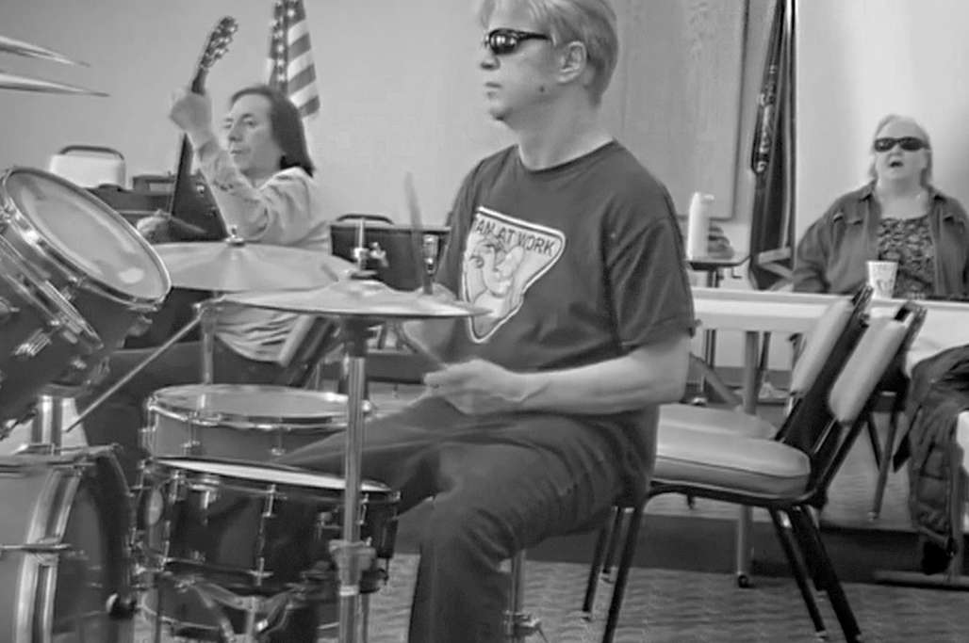The Sights for Hope client band is looking for a drummer and a bass player. Interested clients should call Rita Lang at
610.433.6018, Ext. 225.

Lehigh Valley Staff Directory

Main Number 610.433.6018
Dennis Zehner, Executive Director and CEO, Ext. 241 Jennifer Pandolfo, Associate Director/Dir. of Services, Ext. 223 Deirdre Federico Snyder, Director of Advancement, Ext. 244 Nancy Cobb, Operations Manager, Ext. 242
Rita Lang, Client Activities Manager, Ext. 225 Enid Cruz, Client Services Assistant, Ext. 240
Dianne Michels, Vision Rehabilitation Therapist, Ext. 230 Stephanie Guillen, Client Caseworker, Ext. 246
Erin Hahn, Client Caseworker, Ext. 231 Erica Vibert, Client Caseworker, Ext. 227
Kim Williams, Low Vision Care Coordinator, Ext. 224 Brian Schell, Transport Coordinator, Ext. 226
Ruthie Asmus, Prevention Specialist, Ext. 248 Colleen Rountree, Prevention Specialist, Ext. 245

Monroe Staff Directory

Main Number 570.992.7787
Jennifer Pandolfo, Associate Director/Dir. of Services, Ext. 222 Yvette Quintero, Lead Client Caseworker, Ext. 221
Melinda Weston, Client Caseworker, Ext. 228 Cheryl Miller, Low Vision Care Coordinator, Ext. 229 Lisa Metcalf, Transport Coordinator, Ext. 224 Angela Hill, Prevention Specialist, Ext. 223

FREE MATTER FOR THE BLIND OR PHYSICALLY HANDICAPPED
Post Manual Part 138

Client Bulletin

This bulletin is a public service provided in part by

DESIGN | PRINT | FINISH | MAIL

This publication © 2023 Sights for Hope

