™

™

Client Bulletin

April 2023 | Volume 12, Issue 10.1
This bulletin lists Sights for Hope’s life skills education programs, peer support groups, and activities for its clients in the Lehigh Valley and Monroe County.

Large-Print Pullout Calendars
- Lehigh Valley: Pages 9 and 12
- Monroe: Pages 10-11
Designed to be pulled apart and displayed

Lehigh Valley Services Center
845 West Wyoming St., Allentown, PA 18103

610.433.6018
Monroe Services Center
4215 Manor Drive, Stroudsburg, PA 18360
570.992.7787

Choose How You Receive Your Client Bulletin
You can choose how you receive this bulletin. Your choices are listed below.

- Receive it in the postal mail in large print
- Receive it in the postal mail in extra-large print
- Receive it in the postal mail as a braille document
- Receive it as an audio file on a USB drive
- Receive it as an email message
- Download it in Word or PDF formats at

SightsforHope.org/Bulletins
- Listen to it online at SightsforHope.org/Bulletins

Please contact your caseworker if you want to change the way you receive the bulletin.

How to Schedule Transportation
Call one of our transport coordinators Monday-Friday from 8:30 a.m.-4:30 p.m. to schedule a ride.
Lehigh Valley
Brian Schell, 610.433.6018, Ext. 226
Monroe County
Lisa Metcalf, 570.992.7787, Ext. 224

- What’s Exciting

Enid Cruz Joins Sights for Hope’s Client Services Team
Enid Cruz has joined Sights for Hope’s services team as its Client Services Assistant.

Enid, who served as a temporary Client Caseworker from
January-March, will serve as Sights for Hope’s initial point of contact for
potential clients. She also will assist caseworkers by performing functions such as client intakes and annual client service reviews.

Enid’s professional experiences include work as a teacher for the Elevation Child Care Center in Allentown; work as an in-home support worker for Access Services in Bethlehem; work as an employment counselor for what

Continued on Next Page

is now the Hispanic Center Lehigh Valley; and service as the Hispanic Community Coordinator for the Midway Manor Community Association. She is a graduate of Liberty High School in Bethlehem, PA, and has studied Special Education at Northampton Community College.

Lehigh Valley Client Caseworker Stephanie Guillen, for whom Enid was substituting, has returned to her position.

Updated Information Provided for Beacon Lodge Transportation
Transportation information has been updated for this year’s Pennsylvania Lions Beacon Lodge camp. The bus will depart from the former Kmart store on Tilghman Street in Allentown on Saturday, July 15, and return on Tuesday, July 25.

The updated information is that interested clients should send a check by Wednesday, July 5, for $80, payable to Springfield Lions Club, by mail to:
John Anderson
1829 East Madison St. Philadelphia, PA 19134
Phone 215.410.8524

Musicians Wanted for Client Band
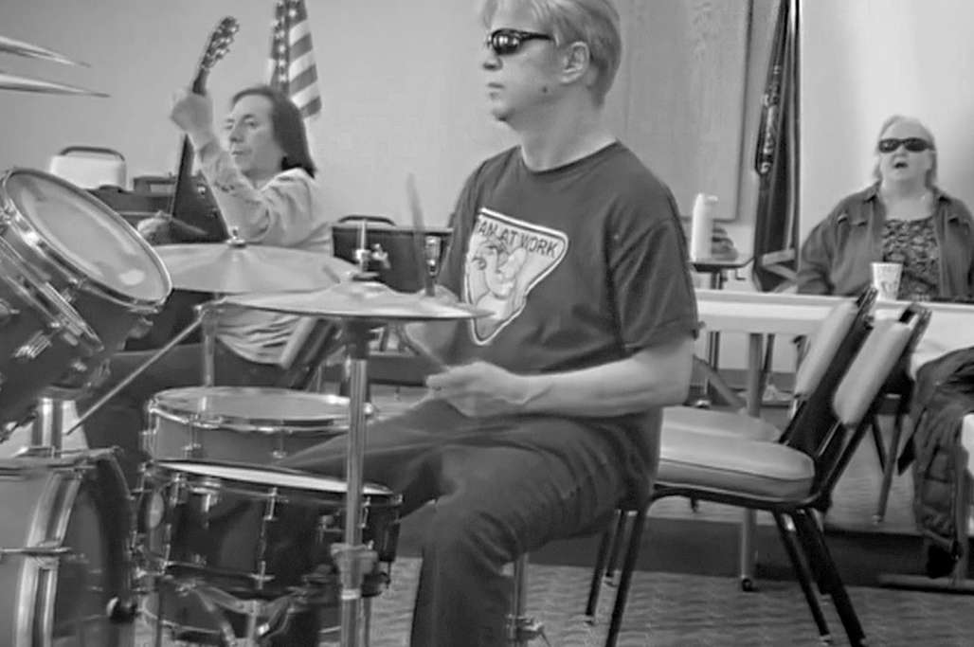The Sights for Hope client band is looking for a drummer and a bass player. Interested clients should call Rita Lang at
610.433.6018, Ext. 225.

DeSales University to Present Two Audio-Described Performances
DeSales University will present an audio-described performance of The Wonderful Wizard of Oz on Saturday, April 1, at a 10 a.m. and of The Hunchback of Notre Dame on Saturday, May 6, at 2 p.m. Audio description or open captioning services can be reserved by calling the DeSales box office at 610.282.1100.

Bilingual Support Group to be Held by Neighborhood Health Center
The Neighborhood Health Center of the Lehigh Valley at 160 Hamilton St. in Allentown, PA, hosts a bilingual support group for people with visual impairments.
Sessions are held on the first Wednesday of each month
from 3-4:30 p.m. Call 610.477.0105 for details.

Life Skills Education Programs

Tech Talks
  - Who Can Participate: All clients
  - Dates and Times: Thursdays, April 6, 13, 20, and 27,

2-3:30 p.m.
  - Virtual Connections: Go to SightsforHope.org/Events

Spring Salads
Create healthy spring salads with Dianne Michels.
  - Who Can Participate: Lehigh Valley clients
  - Date and Time: Tuesday, April 18, 10:30 a.m.- 1 p.m.
  - Location: Lehigh Valley Services Center
  - Registration: Rita Lang at 610.433.6018, Ext. 225
  - Who Can Schedule Transportation: Lehigh Valley clients
  - Virtual Connections: Go to SightsforHope.org/Events

Life Skills Education Programs

iOS Device Workshop
Learn about the iPhone and iPad. Please bring a lunch or money to order.
  - Who Can Participate: All clients
  - Date and Time: Wednesday, April 19, 11 a.m.- 1 p.m.
  - Location: Lehigh Valley Services Center
  - Registration: Rita Lang at 610.433.6018, Ext. 225
  - Who Can Schedule Transportation: Not available
  - Virtual Connections: Go to SightsforHope.org/Events

Peer Support Groups

Monroe Client Group
Facilitated by James Van Horn.
  - Who Can Participate: Monroe clients
  - Date and Time: Monday, April 3, 10-11:30 a.m.
  - Location: Monroe Services Center
  - Registration: Lisa Metcalf at 570.992.7787, Ext. 224
  - Who Can Schedule Transportation: Monroe clients
  - Virtual Connections: Go to SightsforHope.org/Events

Peer Support Groups

Lehigh Valley Client Group
Facilitated by James Van Horn.
  - Who Can Participate: Lehigh Valley clients
  - Date and Time: Thursday, April 6, 10-11:30 a.m.
  - Location: Lehigh Valley Services Center
  - Registration: Rita Lang at 610.433.6018, Ext. 225
  - Who Can Schedule Transportation: Lehigh Valley clients
  - Virtual Connections: Go to SightsforHope.org/Events

Women’s Client Group
  - Who Can Participate: All female clients
  - Date and Time: Tuesday, April 11, 10-11 a.m.
  - Location: Lehigh Valley Services Center
  - Registration: Rita Lang at 610.433.6018, Ext. 225
  - Who Can Schedule Transportation: Not available
  - Virtual Connections: Go to SightsforHope.org/Events

- Descriptions Continue on Page 13

April 2023

Lehigh Valley Client Calendar
Thursday | Friday | Saturday
 |  | 1
6  Lehigh Vly Group  10-11:30 | 7 | 8  GLVNFB Mtg 10-12
13 | 14 | 15  LVCB Mtg 10-12
20 | 21 | 22
27Visionaries  10:30-12:30  LV Lions 12:30-1:30 | 28 | 29

Want to Do More?
Most Monroe activities also are open to Lehigh Valley clients who can arrange their own rides.
Check out the descriptions for details.

- Weekly Services Mall Walks
April 5, 12,
19, and 26,
9-10:30

Tech Talks
April 6, 13,
20, and 27,
2-3:30

April 2023
Monroe Client Calendar

Sunday | Monday | Tuesday | Wednesday
2 | 3  Monroe Group 10-11:30 | 4 | 5
9 | 10 | 11 | 12
16 | 17  Bowling and Pizza 11:30-2 | 18 | 19
23  30 | 24  Musicians 11-1 | 25  Spring Fling 12-2 | 26

April 2023

Monroe Client Calendar
Thursday | Friday | Saturday
 |  | 1
6 | 7 | 8
13  Wind Chimes 10-11:30 | 14 | 15
20 | 21 | 22
27 | 28 NuVisions  10:30-12  Monroe Lions 1-2 | 29

Want to Do More?
Most Lehigh Valley activities also are open to Monroe clients who can arrange their own rides.
Check out the descriptions for details.

Weekly Services
Tech Talks
April 6, 13,
20, and 27,
2-3:30

April 2023
Lehigh Valley Client Calendar

Sunday | Monday | Tuesday | Wednesday
2 | 3 | 4 | 5
9 | 10 | 11 Women’s  Group  10-11  Crafters 11-1 | 12
16 | 17 | 18  Salads 10:30-1 | 19  iOS Devices 11-1
23  30 | 24 Dominoes  10-11:30  Musicians 11-1 | 25 | 26

Activities

Mall Walks
    - Who Can Participate: All clients
    - Dates and Times: Wednesdays, April 5, 12, 19, and 26,

9-10:30 a.m.
    - Location: South Mall, 3300 Lehigh St., Allentown, PA
    - Who Can Schedule Transportation: Lehigh Valley clients

Crafters Corner Activity
    - Who Can Participate: All clients
    - Date and Time: Tuesday, April 11, 11 a.m.-1 p.m.
    - Location: Lehigh Valley Services Center
    - Registration: Rita Lang at 610.433.6018, Ext. 225
    - Who Can Schedule Transportation: Not available

Wind Chime Craft Making
Create auditory art from clay pots.
    - Who Can Participate: All clients
    - Date and Time: Thursday, April 13, 10-11:30 a.m.
    - Location: Monroe Services Center
    - Registration: Lisa Metcalf at 570.992.7787, Ext. 224
    - Who Can Schedule Transportation: Not available

Activities

Bowling and Pizza in Wind Gap
Enjoy an afternoon of bowling and pizza in Wind Gap with your fellow clients. The cost for bowling is $3.00 per game plus the price of shoe rental.
    - Who Can Participate: All clients
    - Date and Time: Monday, April 17, 11:30 a.m.-2 p.m.

Locations: Sal’s Pizza, 487 East Moorestown Road, Wind Gap, PA; and Blue Ridge Lanes, 505 East Moorestown Road, Wind Gap, PA
    - Registration: Lisa Metcalf at 570.992.7787, Ext. 224
    - Who Can Schedule Transportation: Not available

Dominoes for Spanish-Speaking Clients
- Who Can Participate: All Spanish-speaking clients
- Date and Time: Monday, April 24, 10-11:30 a.m.
- Location: Lehigh Valley Services Center
- Registration: Stephanie Guillen at 610.433.6018, Ext. 246
- Who Can Schedule Transportation: Lehigh Valley clients

Activities

Musician Jam Session
    - Who Can Participate: All clients who are musicians and/or vocalists
    - Date and Time: Monday, April 24, 11 a.m.-1 p.m.
    - Location: Monroe Services Center
    - Who Can Schedule Transportation: Lehigh Valley and Monroe clients

NuVisions Spring Fling
This activity is organized by the NuVisions client group but is open to all clients. Come enjoy friendship and great food from Angel’s Cafe & Catering in Stroudsburg, PA. Friends and family members are welcome. The cost is
$23 per person.
    - Who Can Participate: All Monroe clients
    - Date and Time: Tuesday, April 25, 12-2 p.m.
    - Location: Monroe Services Center

Registration: Jennifer Pandolfo at 570.992.7787, Ext. 223; or Lisa Metcalf at 570.992.7787, Ext. 224
    - Who Can Schedule Transportation: Monroe clients

Activities

Visionaries Client Group Activity
Make textured art with Michael Freeman and take part in the fourth of a six-part series on mindfulness. This activity is organized by the Visionaries client group but is open to all Lehigh Valley clients. Please note that the Lehigh Valley Sights for Hope Lions Club will meet after this activity.
    - Who Can Participate: All Lehigh Valley clients
    - Date and Time: Thursday, April 27, 10:30 a.m.- 12:30 p.m.
    - Location: Lehigh Valley Services Center
    - Who Can Schedule Transportation: Lehigh Valley clients

NuVisions Client Group Activity
Corrine Belanger, O.D., from Stroudsburg Eye Specialists will discuss eye diseases and answer questions. This activity is organized by the NuVisions client group but is open to all Monroe clients.
    - Who Can Participate: All Monroe clients
    - Date and Time: Friday, April 28, 10:30 a.m.-12 p.m.
    - Location: Monroe Services Center
    - Registration: Jennifer Pandolfo at 570.992.7787, Ext. 223
    - Who Can Schedule Transportation: Monroe clients

Meetings

LV Sights for Hope Lions Club Meeting The Lehigh Valley Sights for Hope Lions Club will hold its monthly meeting. All clients who live in Lehigh and Northampton counties are welcome.
    - Who Can Participate: All Lehigh Valley clients
    - Date and Time: Thursday, April 27, 12:30-1:30 p.m.
    - Location: Lehigh Valley Services Center
    - Additional Details: SightsforHope.org/LVLionsClub

Monroe Sights for Hope Lions Club Meeting The Monroe Sights for Hope Lions Club will hold its monthly meeting. All clients who live in Monroe County are welcome. Participants are encouraged to bring a lunch or
money to order.
    - Who Can Participate: All Monroe clients
    - Date and Time: Friday, April 28, 1-2 p.m.
    - Location: Monroe Services Center
    - Registration: Jennifer Pandolfo, 570.992.7787, Ext. 222
    - Who Can Schedule Transportation: Monroe clients
    - Additional Details: SightsforHope.org/MonroeLionsClub

Meetings

Greater LV Chapter - National Federation of the Blind (GLVNFB) Meeting
    - Date and Time: Saturday, April 8, 10 a.m.-12 p.m.

Location: Denny’s Restaurant, 1871 Catasauqua Road, Allentown, PA
    - Additional Details: Call Kirk Hunger at 484.239.0741

LV Council of the Blind (LVCB) Meeting
Please bring a lunch or money to order.
    - Who Can Participate: LVCB members
    - Date and Time: Saturday, April 15, 10 a.m.-12 p.m.
    - Location: Lehigh Valley Services Center
    - Additional Details: Write to LVCB1993@gmail.com

Lehigh Valley Staff Directory

Main Number 610.433.6018
Dennis Zehner, Executive Director and CEO, Ext. 241 Jennifer Pandolfo, Associate Director/Dir. of Services, Ext. 223 Deirdre Federico Snyder, Director of Advancement, Ext. 244 Nancy Cobb, Operations Manager, Ext. 242
Rita Lang, Client Activities Manager, Ext. 225 Enid Cruz, Client Services Assistant, Ext. 240
Dianne Michels, Vision Rehabilitation Therapist, Ext. 230 Stephanie Guillen, Client Caseworker, Ext. 246
Erin Hahn, Client Caseworker, Ext. 231 Erica Vibert, Client Caseworker, Ext. 227
Kim Williams, Low Vision Care Coordinator, Ext. 224 Brian Schell, Transport Coordinator, Ext. 226
Ruthie Asmus, Prevention Specialist, Ext. 248 Colleen Rountree, Prevention Specialist, Ext. 245

Monroe Staff Directory

Main Number 570.992.7787
Jennifer Pandolfo, Associate Director/Dir. of Services, Ext. 222 Yvette Quintero, Lead Client Caseworker, Ext. 221
Melinda Weston, Client Caseworker, Ext. 228 Cheryl Miller, Low Vision Care Coordinator, Ext. 229 Lisa Metcalf, Transport Coordinator, Ext. 224 Angela Hill, Prevention Specialist, Ext. 223

FREE MATTER FOR THE BLIND OR PHYSICALLY HANDICAPPED
Post Manual Part 138

Client Bulletin

This bulletin is a public service provided in part by

DESIGN | PRINT | FINISH | MAIL

This publication © 2023 Sights for Hope

