™

™

Client Bulletin

March 2023 | Volume 12, Issue 9.1
This bulletin lists Sights for Hope’s life skills education programs, peer support groups, and activities for its clients in the Lehigh Valley and Monroe County.

Large-Print Pullout Calendars
- Lehigh Valley: Pages 9 and 12
- Monroe: Pages 10-11
Designed to be pulled apart and displayed

Lehigh Valley Services Center
845 West Wyoming St., Allentown, PA 18103

610.433.6018
Monroe Services Center
4215 Manor Drive, Stroudsburg, PA 18360
570.992.7787

Choose How You Receive Your Client Bulletin
You can choose how you receive this bulletin. Your choices are listed below.

- Receive it in the postal mail in large print
- Receive it in the postal mail in extra-large print
- Receive it in the postal mail as a braille document
- Receive it as an audio file on a USB drive
- Receive it as an email message
- Download it in Word or PDF formats at

SightsforHope.org/Bulletins
- Listen to it online at SightsforHope.org/Bulletins

Please contact your caseworker if you want to change the way you receive the bulletin.

How to Schedule Transportation
Call one of our transport coordinators Monday-Friday from 8:30 a.m.-4:30 p.m. to schedule a ride.
Lehigh Valley
Brian Schell, 610.433.6018, Ext. 226
Monroe County
Lisa Metcalf, 570.992.7787, Ext. 224

- What’s Exciting

Bakery Holds Fundraiser for Monroe Sights for Hope Lions Club
Tomblers Bakery in Easton, PA, is holding a fundraiser to benefit the Monroe Sights for Hope Lions Club.

The bakery is selling several items with proceeds benefiting the club. The items include breakfast pasties for
$4.50 each; various additional pasties (including beef, chicken, sausage, ham and cheese and veggie) for
$7.00 each; large shoofly pies for $7.50 each; apple dumplings for $4.50 each; and eight-inch cherry and apple pies for $13.00 each.

Order forms must be received at Sights for Hope’s Monroe Services Center by March 17, and the items can be picked up there on April 3. Interested clients should call Jennifer Pandolfo at 570.992.7787, Ext. 222.

Transportation Available for this Summer’s Beacon Lodge Trip
Reservations for transportation to this year’s Pennsylvania Lions Beacon Lodge camp for adults are now available. The bus will depart from the former Kmart store on Tilghman Street in Allentown on Saturday, July 15, and return on Tuesday, July 25.
Interested clients should send a check for $70, payable
to Springfield Lions Club, by mail to:
John Anderson
1829 East Madison St. Philadelphia, PA 19134
Phone 215.410.8524

Musicians Wanted for Client Band
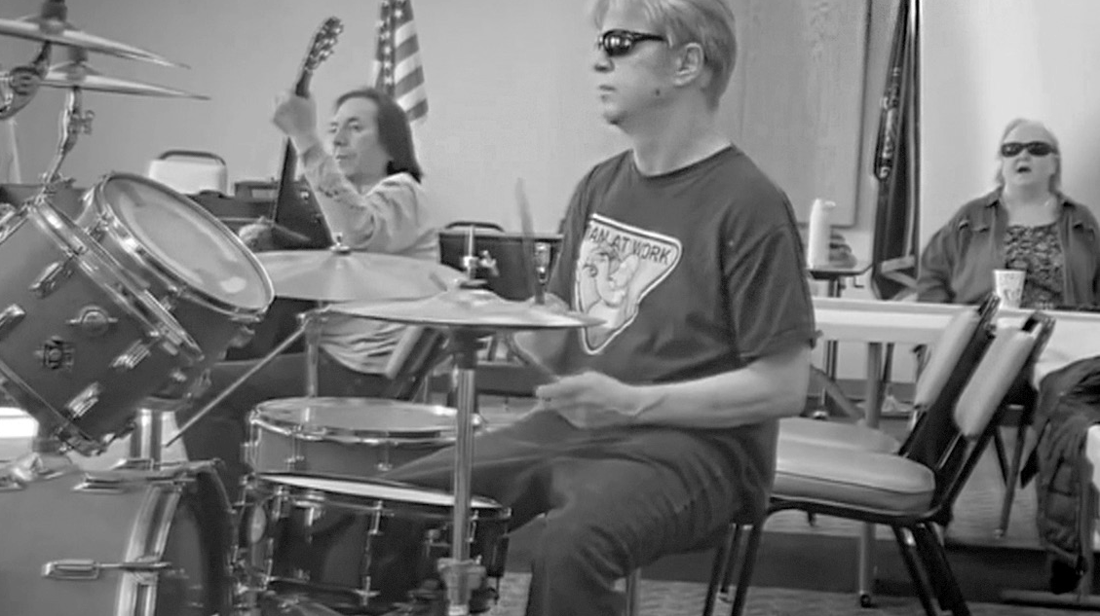The Sights for Hope client band is looking for a drummer and a bass player. Interested clients should call Rita Lang at 610.433.6018, Ext. 225.

Life Skills Education Programs

Tech Talks
  - Who Can Participate: All clients
  - Dates and Times: Thursdays, March 2, 9, 16, 23, and

30, 2-3:30 p.m.
  - Virtual Connections: Go to SightsforHope.org/Events

iOS Device Workshop
Learn about the iPhone and iPad. Please bring a lunch or money to order.
  - Who Can Participate: All clients
  - Date and Time: Wednesday, March 15, 11 a.m.- 1 p.m.
  - Location: Lehigh Valley Services Center
  - Registration: Rita Lang at 610.433.6018, Ext. 225
  - Who Can Schedule Transportation: Not available
  - Virtual Connections: Go to SightsforHope.org/Events

Life Skills Education Programs

Adaptive Writing for Everyday Living
Learn techniques for writing lists, notes, and scheduled appointments. Facilitated by Dianne Michels.
  - Who Can Participate: All clients
  - Dates and Times: Thursday, March 16, 10:30 a.m.- 1 p.m.
  - Location: Lehigh Valley Services Center
  - Registration: Rita Lang at 610.433.6018, Ext. 225
  - Who Can Schedule Transportation: Lehigh Valley clients

Beginner Braille in Monroe
Our Beginner Braille program in Monroe County is taught by Sights for Hope client Jasmyn Polite.
  - Who Can Participate: All clients
  - Dates and Times: Friday, March 17, 10:30 a.m.- 1 p.m.
  - Location: Monroe Services Center
  - Registration: Lisa Metcalf at 570.992.7787, Ext. 224
  - Who Can Schedule Transportation: Monroe clients

Peer Support Groups

Lehigh Valley Client Group
Facilitated by James Van Horn.
  - Who Can Participate: Lehigh Valley clients
  - Date and Time: Thursday, March 2, 10-11:30 a.m.
  - Location: Lehigh Valley Services Center
  - Registration: Rita Lang at 610.433.6018, Ext. 225
  - Who Can Schedule Transportation: Lehigh Valley clients
  - Virtual Connections: Go to SightsforHope.org/Events

Monroe Client Group
Facilitated by James Van Horn.
  - Who Can Participate: Monroe clients
  - Date and Time: Monday, March 6, 10-11:30 a.m.
  - Location: Monroe Services Center
  - Registration: Lisa Metcalf at 570.992.7787, Ext. 224
  - Who Can Schedule Transportation: Monroe clients
  - Virtual Connections: Go to SightsforHope.org/Events

Peer Support Groups

Women’s Client Group
  - Who Can Participate: All female clients
  - Date and Time: Tuesday, March 14, 10-11 a.m.
  - Location: Lehigh Valley Services Center
  - Registration: Rita Lang at 610.433.6018, Ext. 225
  - Who Can Schedule Transportation: Not available
  - Virtual Connections: Go to SightsforHope.org/Events

- Descriptions Continue on Page 13

March 2023

Lehigh Valley Client Calendar
Thursday | Friday | Saturday
2  Lehigh Vly Group  10-11:30 | 3 | 4
9 | 10 | 11  GLVNFB Mtg 10-12
16  Adaptive Writing 10:30-1 | 17 | 18  LVCB Mtg 10-1
23  Dominoes 10-11:30 | 24 | 25
30Visionaries  10:30-12:30  LV Lions 12:30-1:30 | 31

Want to Do More?
Most Monroe activities also are open to Lehigh Valley clients who can arrange their own rides.
Check out the descriptions for details.

- Weekly Services Mall Walks
March 1, 8,
15, 22, and
29, 9-10:30

Tech Talks
March 2, 9
16, 23, and
30, 2-3:30

March 2023
Monroe Client Calendar

Sunday | Monday | Tuesday | Wednesday
 |  |  | 1
5 | 6  Monroe Group 10-11:30 | 7 | 8
12 | 13 | 14 | 15  Swimming 10-12
19 | 20 | 21  Accessible Movies  11-2 | 22
26 | 27  Musicians 11-1 | 28 | 29

March 2023

Monroe Client Calendar
Thursday | Friday | Saturday
2 | 3 | 4
9 | 10 | 11
16 | 17  Beginner Braille 10:30-1 | 18
23 | 24 | 25
30 | 31 NuVisions  10:30-12  Monroe Lions 1-2

Want to Do More?
Most Lehigh Valley activities also are open to Monroe clients who can arrange their own rides.
Check out the descriptions for details.

Weekly Services
Tech Talks
March 2, 9,
16, 23, and
30, 2-3:30

March 2023
Lehigh Valley Client Calendar

Sunday | Monday | Tuesday | Wednesday
 |  |  | 1
5 | 6 | 7 | 8
12 | 13 | 14Women’s  Group  10-11  Crafters 11-1 | 15  iOS Devices 11-1
19 | 20 | 21 | 22
26 | 27  Musicians 11-1 | 28 | 29

Activities

Mall Walks
    - Who Can Participate: All clients
    - Dates and Times: Wednesdays, March 1, 8, 15, 22,

and 29, 9-10:30 a.m.
    - Location: South Mall, 3300 Lehigh St., Allentown, PA
    - Who Can Schedule Transportation: Lehigh Valley clients

Crafters Corner Activity
    - Who Can Participate: All clients
    - Date and Time: Tuesday, March 14, 11 a.m.-1 p.m.
    - Location: Lehigh Valley Services Center
    - Registration: Rita Lang at 610.433.6018, Ext. 225
    - Who Can Schedule Transportation: Not available

Activities

Swimming at Shawnee Inn and Resort - Rescheduled
Enjoy the pool and hot tub at the Shawnee Inn and Resort.
    - Who Can Participate: All Monroe clients
    - Date and Time: Tuesday, March 15, 10 a.m.-12 p.m.

Location: Shawnee Inn, 100 Shawnee Inn Drive, Shawnee on Delaware, PA
    - Who Can Schedule Transportation: Monroe clients

Accessible Movies
Learn about audio-described performances by hearing verbal descriptions of a movie in a stereo headset. The movies cost $6.00 and will be determined by availability.
- Who Can Participate: All clients
- Date and Time: Tuesday, March 21, 11 a.m.-2 p.m.

Location: Cinemark Theater, 160 Stroud Mall, Stroudsburg, PA
- Who Can Schedule Transportation: Monroe clients

Activities

Dominoes for Spanish-Speaking Clients
    - Who Can Participate: All Spanish-speaking clients
    - Date and Time: Thursday, March 23, 10-11:30 a.m.
    - Location: Lehigh Valley Services Center
    - Registration: Enid Cruz at 610.433.6018, Ext. 246
    - Who Can Schedule Transportation: Lehigh Valley clients

Musician Jam Session
      - Who Can Participate: All clients who are musicians and/or vocalists
      - Date and Time: Monday, March 27, 11 a.m.-1 p.m.
      - Location: Monroe Services Center
      - Who Can Schedule Transportation: Lehigh Valley and Monroe clients

Activities

Visionaries Client Group Activity
The March activity is the third of a six-part series on mindfulness and a presentation on accessible transportation. This activity is organized by the Visionaries client group but is open to all Lehigh Valley clients. Please note that the Lehigh Valley Sights for Hope Lions Club will meet after this activity.
    - Who Can Participate: All Lehigh Valley clients
    - Date and Time: Thursday, March 30, 10:30 a.m.- 12:30 p.m.
    - Location: Lehigh Valley Services Center
    - Who Can Schedule Transportation: Lehigh Valley clients

NuVisions Client Group Activity
This activity is organized by the NuVisions client group but is open to all Monroe clients.
    - Who Can Participate: All Monroe clients
    - Date and Time: Friday, March 31, 10:30 a.m.- 12 p.m.
    - Location: Monroe Services Center
    - Registration: Jennifer Pandolfo at 570.992.7787, Ext. 223
    - Who Can Schedule Transportation: Monroe clients

Meetings

LV Sights for Hope Lions Club Meeting The Lehigh Valley Sights for Hope Lions Club will hold its monthly meeting. All clients who live in Lehigh and Northampton counties are welcome.
    - Who Can Participate: All Lehigh Valley clients
    - Date and Time: Thursday, March 30, 12:30-1:30 p.m.
    - Location: Lehigh Valley Services Center
    - Additional Details: SightsforHope.org/LVLionsClub

Monroe Sights for Hope Lions Club Meeting The Monroe Sights for Hope Lions Club will hold its monthly meeting. All clients who live in Monroe County are welcome. Participants are encouraged to bring a lunch or
money to order.
    - Who Can Participate: All Monroe clients
    - Date and Time: Friday, March 31, 1-2 p.m.
    - Location: Monroe Services Center
    - Registration: Jennifer Pandolfo, 570.992.7787, Ext. 222
    - Who Can Schedule Transportation: Monroe clients
    - Additional Details: SightsforHope.org/MonroeLionsClub

Meetings

Greater LV Chapter - National Federation of the Blind (GLVNFB) Meeting
    - Date and Time: Saturday, March 11, 10 a.m.-12 p.m.

Location: Denny’s Restaurant, 1871 Catasauqua Road, Allentown, PA
    - Additional Details: Call Kirk Hunger at 484.239.0741

LV Council of the Blind (LVCB) Meeting
Please bring a lunch or money to order.
    - Who Can Participate: LVCB members
    - Date and Time: Saturday, March 18, 10 a.m.-1 p.m.
    - Location: Lehigh Valley Services Center
    - Additional Details: Write to LVCB1993@gmail.com

Lehigh Valley Staff Directory

Main Number 610.433.6018
Dennis Zehner, Executive Director and CEO, Ext. 241 Jennifer Pandolfo, Associate Director/Dir. of Services, Ext. 223 Deirdre Federico Snyder, Director of Advancement, Ext. 244 Nancy Cobb, Operations Manager, Ext. 242
Rita Lang, Client Activities Manager, Ext. 225 Teresa Pickett, Services Coordinator, Ext. 240
Dianne Michels, Vision Rehabilitation Therapist, Ext. 230 Stephanie Guillen, Client Caseworker, Ext. 246
Erin Hahn, Client Caseworker, Ext. 231 Erica Vibert, Client Caseworker, Ext. 227
Kim Williams, Low Vision Care Coordinator, Ext. 224 Brian Schell, Transport Coordinator, Ext. 226
Ruthie Asmus, Prevention Specialist, Ext. 248 Colleen Rountree, Prevention Specialist, Ext. 245

Monroe Staff Directory

Main Number 570.992.7787
Jennifer Pandolfo, Associate Director/Dir. of Services, Ext. 222 Teresa Pickett, Services Coordinator, Ext. 222
Yvette Quintero, Lead Client Caseworker, Ext. 221 Melinda Weston, Client Caseworker, Ext. 228 Cheryl Miller, Low Vision Care Coordinator, Ext. 229 Lisa Metcalf, Transport Coordinator, Ext. 224 Angela Hill, Prevention Specialist, Ext. 223

FREE MATTER FOR THE BLIND OR PHYSICALLY HANDICAPPED
Post Manual Part 138

Client Bulletin

This bulletin is a public service provided in part by

DESIGN | PRINT | FINISH | MAIL

This publication © 2023 Sights for Hope

