™

™

Client Bulletin

February 2023 | Volume 12, Issue 8.1
This bulletin lists Sights for Hope’s life skills education programs, peer support groups, and activities for its clients in the Lehigh Valley and Monroe County.

Large-Print Pullout Calendars
- Lehigh Valley: Pages 9 and 12
- Monroe: Pages 10-11
Designed to be pulled apart and displayed

Lehigh Valley Services Center
845 West Wyoming St., Allentown, PA 18103

610.433.6018
Monroe Services Center
4215 Manor Drive, Stroudsburg, PA 18360
570.992.7787

Choose How You Receive Your Client Bulletin
You can choose how you receive this bulletin. Your choices are listed below.

- Receive it in the postal mail in large print
- Receive it in the postal mail in extra-large print
- Receive it in the postal mail as a braille document
- Receive it as an audio file on a USB drive
- Receive it as an email message
- Download it in Word or PDF formats at

SightsforHope.org/Bulletins
- Listen to it online at SightsforHope.org/Bulletins

Please contact your caseworker if you want to change the way you receive the bulletin.

How to Schedule Transportation
Call one of our transport coordinators Monday-Friday from 8:30 a.m.-4:30 p.m. to schedule a ride.
Lehigh Valley
Brian Schell, 610.433.6018, Ext. 226
Monroe County
Lisa Metcalf, 570.992.7787, Ext. 224

- What’s Exciting

Sights for Hope Marks Milestone with Advanced Braille Graduation
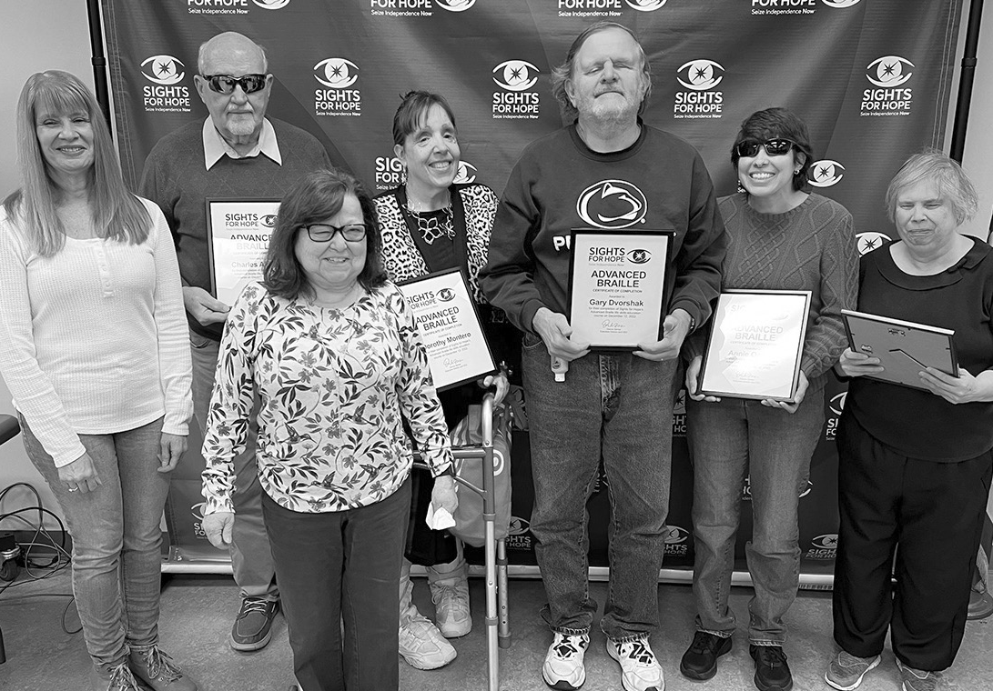Sights for Hope held a graduation recently for the first clients in more than 40 years to
complete its Advanced Braille life skills education program.

The four graduates
studied what is known as grade 2 Braille, or contracted Braille, for more than two years. When the COVID-19 pandemic began, they figured out how to press on by phone with their instructor – Vision Rehabilitation Therapist Dianne Michels – and volunteer teaching assistant Annette Gozzard. They also met on their own and quizzed each other almost daily by text message.

The graduating class was the first that Michels has taught at Sights for Hope – an organization for which she has worked for 24 years over three tenures since 1980.

Continued on Next Page

Contracted Braille is a form practiced by people who desire to read and become more immersed in Braille. It uses the same letters, punctuations, and numbers as grade 1 Braille, or uncontracted Braille. Grade 2 Braille adds symbols for letter combinations such as “ch” and “th,” compressed abbreviations for many words, and special symbols for suffixes. Grade 2 Braille requires
more extensive memorization and its rules are complex and somewhat ambiguous. All Braille books are written in what professionals say is an extremely complex code. Most people who develop a visual impairment learn only the alphabet in Braille and find it useful in their daily lives.

Free Braille Calendars Available from American Action Fund
Free 2023 Braille calendars can be ordered from the American Action Fund for Blind Children and Adults by going to ActionFund.org/resources/braille-calendars on the web or by calling 410.659.9315, Ext. 2236.

Sights for Hope to be Closed February 20 for Presidents Day
Sights for Hope will be closed on Monday, February 20, in observance of Presidents Day. No services will be available that day.

Life Skills Education Programs

Tech Talks
  - Who Can Participate: All clients
  - Dates and Times: Thursdays, February 2, 9, 16, and 23, 2-3:30 p.m.
  - Virtual Connections: Go to SightsforHope.org/Events

Sweet Treats
Come sweeten your Valentine’s Day by baking some treats. Facilitated by Dianne Michels.
  - Who Can Participate: All clients
  - Date and Time: Friday, February 10, 10:30 a.m.- 1 p.m.
  - Location: Lehigh Valley Services Center
  - Registration: Rita Lang at 610.433.6018, Ext. 225
  - Who Can Schedule Transportation: Lehigh Valley clients

Musicians Wanted for Client Band
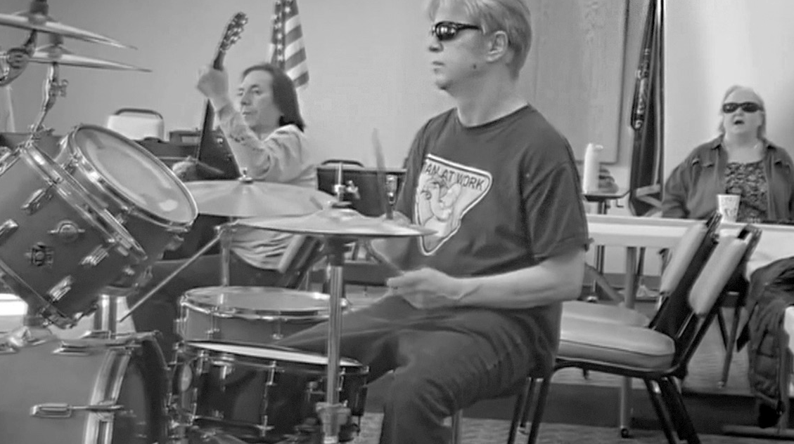The Sights for Hope client band is looking for a drummer and a bass player. Interested clients should call Rita Lang at 610.433.6018, Ext. 225.

Life Skills Education Programs

Beginner Braille in Monroe
This is the first class of our new Beginner Braille program in Monroe County, and it is taught by Sights for Hope client Jasmyn Polite.
  - Who Can Participate: All clients
  - Dates and Times: Friday, February 10, 10:30 a.m.- 1 p.m.
  - Location: Monroe Services Center
  - Registration: Lisa Metcalf at 570.992.7787, Ext. 224
  - Who Can Schedule Transportation: Monroe clients

iOS Device Workshop
Learn about the iPhone and iPad. Please bring a lunch or money to order.
  - Who Can Participate: All clients
  - Date and Time: Wednesday, February 15, 11 a.m.- 1 p.m.
  - Location: Lehigh Valley Services Center
  - Registration: Rita Lang at 610.433.6018, Ext. 225
  - Who Can Schedule Transportation: Not available
  - Virtual Connections: Go to SightsforHope.org/Events

Peer Support Groups

Lehigh Valley Client Group
Facilitated by James Van Horn.
  - Who Can Participate: Lehigh Valley clients
  - Date and Time: Thursday, February 2, 10-11:30 a.m.
  - Location: Lehigh Valley Services Center
  - Registration: Rita Lang at 610.433.6018, Ext. 225
  - Who Can Schedule Transportation: Lehigh Valley clients
  - Virtual Connections: Go to SightsforHope.org/Events

Monroe Client Group
Facilitated by James Van Horn.
  - Who Can Participate: Monroe clients
  - Date and Time: Monday, February 6, 10-11:30 a.m.
  - Location: Monroe Services Center
  - Registration: Lisa Metcalf at 570.992.7787, Ext. 224
  - Who Can Schedule Transportation: Monroe clients
  - Virtual Connections: Go to SightsforHope.org/Events

Peer Support Groups

Women’s Client Group
  - Who Can Participate: All female clients
  - Date and Time: Tuesday, February 14, 10-11 a.m.
  - Location: Lehigh Valley Services Center
  - Registration: Rita Lang at 610.433.6018, Ext. 225
  - Who Can Schedule Transportation: Not available
  - Virtual Connections: Go to SightsforHope.org/Events

- Descriptions Continue on Page 13

February 2023

Lehigh Valley Client Calendar
Thursday | Friday | Saturday
2  Lehigh Vly Group  10-11:30 | 3 | 4
9 | 10  Sweet Treats 10:30-1 | 11  GLVNFB Mtg 10-12
16  Dominoes 10-11:30 | 17 | 18  LVCB Mtg 10-12
23Visionaries  10:30-12:30  LV Lions 12:30-1:30 | 24 | 25

Want to Do More?
Most Monroe activities also are open to Lehigh Valley clients who can arrange their own rides.
Check out the descriptions for details.

- Weekly Services Mall Walks
February 1,
8, 15, and 22,
9-10:30

Tech Talks
February 2,
9 16, and 23,
2-3:30

February 2023
Monroe Client Calendar

Sunday | Monday | Tuesday | Wednesday
 |  |  | 1
5 | 6  Monroe Group 10-11:30 | 7 | 8
12 | 13 | 14  Valentine Makovers 10-12 | 15
19 | 20  Closed for Holiday | 21 | 22
26 | 27  Musicians 11-1 | 28NuVisions  10:30-12  Monroe Lions 1-2

February 2023

Monroe Client Calendar
Thursday | Friday | Saturday
2 | 3 | 4
9 | 10  Beginner Braille 10:30-1 | 11
16 | 17 | 18
23 | 24  Build a Snow Globe 10-12 | 25

Want to Do More?
Most Lehigh Valley activities also are open to Monroe clients who can arrange their own rides.
Check out the descriptions for details.

Weekly Services
Tech Talks
February 2,
9, 16, and 23,
2-3:30

February 2023
Lehigh Valley Client Calendar

Sunday | Monday | Tuesday | Wednesday
 |  |  | 1
5 | 6 | 7 | 8
12 | 13 | 14Women’s  Group  10-11  Crafters 11-1 | 15  iOS Devices 11-1
19 | 20  Closed for Holiday | 21 | 22
26 | 27  Musicians 11-1 | 28

Activities

Mall Walks
    - Who Can Participate: All clients
    - Dates and Times: Wednesdays, February 1, 8, 15,

and 22, 9-10:30 a.m.
    - Location: South Mall, 3300 Lehigh St., Allentown, PA
    - Who Can Schedule Transportation: Lehigh Valley clients

Crafters Corner Activity
    - Who Can Participate: All clients
    - Date and Time: Tuesday, February 14, 11 a.m.- 1 p.m.
    - Location: Lehigh Valley Services Center
    - Registration: Rita Lang at 610.433.6018, Ext. 225
    - Who Can Schedule Transportation: Not available

Activities

Valentine’s Day Makeovers in Monroe
During a time of year that celebrates romance, the love of one’s self remains the most important, and sometimes most difficult, love of all. Enjoy free haircuts and manicures during this popular annual activity.
    - Who Can Participate: All Monroe clients
    - Date and Time: Tuesday, February 14, 10 a.m.- 12 p.m.
    - Location: Monroe Services Center
    - Who Can Schedule Transportation: Monroe clients

Dominoes for Spanish-Speaking Clients
    - Who Can Participate: All Spanish-speaking clients
    - Date and Time: Thursday, February 16, 10-11:30 a.m.
    - Location: Lehigh Valley Services Center
    - Registration: 610.433.6018, Ext. 246
    - Who Can Schedule Transportation: Lehigh Valley clients

Activities

Visionaries Client Group Activity
February’s activity is the second of a six-part series on mindfulness. Create textured art with Michael Freeman. This activity is organized by the Visionaries client group but is open to all Lehigh Valley clients. Please note that the Lehigh Valley Sights for Hope Lions Club will meet after this activity.
    - Who Can Participate: All Lehigh Valley clients
    - Date and Time: Thursday, February 23, 10:30 a.m.- 12:30 p.m.
    - Location: Lehigh Valley Services Center
    - Who Can Schedule Transportation: Lehigh Valley clients

Do You Want to Build a Snow Globe?
Explore your creativity by making this snowy, sensory craft.
    - Who Can Participate: All clients
    - Date and Time: Friday, February 24, 10 a.m.-12 p.m.
    - Location: Monroe Services Center
    - Registration: Lisa Metcalf at 570.992.7787, Ext. 224
    - Who Can Schedule Transportation: Monroe clients

Activities

Musician Jam Session
    - Who Can Participate: All clients who are musicians and/or vocalists
    - Date and Time: Monday, February 27, 11 a.m.-1 p.m.
    - Location: Monroe Services Center
    - Who Can Schedule Transportation: Lehigh Valley and Monroe clients

NuVisions Client Group Activity
This activity is organized by the NuVisions client group but is open to all Monroe clients.
    - Who Can Participate: All Monroe clients
    - Date and Time: Tuesday, February 28, 10:30 a.m.- 12 p.m.
    - Location: Monroe Services Center
    - Registration: Jennifer Pandolfo at 570.992.7787, Ext. 223
    - Who Can Schedule Transportation: Monroe clients

Meetings

LV Sights for Hope Lions Club Meeting The Lehigh Valley Sights for Hope Lions Club will hold its monthly meeting. All clients who live in Lehigh and Northampton counties are welcome.
    - Who Can Participate: All Lehigh Valley clients
    - Date and Time: Thursday, February 23, 12:30- 1:30 p.m.
    - Location: Lehigh Valley Services Center
    - Additional Details: SightsforHope.org/LVLionsClub

Monroe Sights for Hope Lions Club Meeting The Monroe Sights for Hope Lions Club will hold its monthly meeting. All clients who live in Monroe County are welcome. Participants are encouraged to bring a lunch or
money to order.
    - Who Can Participate: All Monroe clients
    - Date and Time: Tuesday, February 28, 1-2 p.m.
    - Location: Monroe Services Center
    - Registration: Jennifer Pandolfo, 570.992.7787, Ext. 222
    - Who Can Schedule Transportation: Monroe clients
    - Additional Details: SightsforHope.org/MonroeLionsClub

Meetings

Greater LV Chapter - National Federation of the Blind (GLVNFB) Meeting
    - Date and Time: Saturday, February 11, 10 a.m.- 12 p.m.

Location: Denny’s Restaurant, 1871 Catasauqua Road, Allentown, PA
    - Additional Details: Call Kirk Hunger at 484.239.0741

LV Council of the Blind (LVCB) Meeting
    - Who Can Participate: LVCB members
    - Date and Time: Saturday, February 18, 10 a.m.- 12 p.m.
    - Location: Lehigh Valley Services Center
    - Additional Details: Write to LVCB1993@gmail.com

Lehigh Valley Staff Directory

Main Number 610.433.6018
Dennis Zehner, Executive Director and CEO, Ext. 241 Jennifer Pandolfo, Associate Director/Dir. of Services, Ext. 223 Deirdre Federico Snyder, Director of Advancement, Ext. 244 Nancy Cobb, Operations Manager, Ext. 242
Rita Lang, Client Activities Manager, Ext. 225 Teresa Pickett, Services Coordinator, Ext. 240
Dianne Michels, Vision Rehabilitation Therapist, Ext. 230 Stephanie Guillen, Client Caseworker, Ext. 246
Erin Hahn, Client Caseworker, Ext. 231 Erica Vibert, Client Caseworker, Ext. 227
Kim Williams, Low Vision Care Coordinator, Ext. 224 Brian Schell, Transport Coordinator, Ext. 226
Ruthie Asmus, Prevention Specialist, Ext. 248 Colleen Rountree, Prevention Specialist, Ext. 245

Monroe Staff Directory

Main Number 570.992.7787
Jennifer Pandolfo, Associate Director/Dir. of Services, Ext. 222 Teresa Pickett, Services Coordinator, Ext. 222
Yvette Quintero, Lead Client Caseworker, Ext. 221 Melinda Weston, Client Caseworker, Ext. 228 Cheryl Miller, Low Vision Care Coordinator, Ext. 229 Lisa Metcalf, Transport Coordinator, Ext. 224 Angela Hill, Prevention Specialist, Ext. 223

FREE MATTER FOR THE BLIND OR PHYSICALLY HANDICAPPED
Post Manual Part 138

Client Bulletin

This bulletin is a public service provided in part by

DESIGN | PRINT | FINISH | MAIL

This publication © 2023 Sights for Hope

