™

™

Client Bulletin

January 2023 | Volume 12, Issue 7.1
This bulletin lists Sights for Hope’s life skills education programs, peer support groups, and activities for its clients in the Lehigh Valley and Monroe County.

Large-Print Pullout Calendars
- Lehigh Valley: Pages 9 and 12
- Monroe: Pages 10-11
Designed to be pulled apart and displayed

Lehigh Valley Services Center
845 West Wyoming St., Allentown, PA 18103

610.433.6018
Monroe Services Center
4215 Manor Drive, Stroudsburg, PA 18360
570.992.7787

Choose How You Receive Your Client Bulletin
You can choose how you receive this bulletin. Your choices are listed below.

- Receive it in the postal mail in large print
- Receive it in the postal mail in extra-large print
- Receive it in the postal mail as a braille document
- Receive it as an audio file on a USB drive
- Receive it as an email message
- Download it in Word or PDF formats at

SightsforHope.org/Bulletins
- Listen to it online at SightsforHope.org/Bulletins

Please contact your caseworker if you want to change the way you receive the bulletin.

How to Schedule Transportation
Call one of our transport coordinators Monday-Friday from 8:30 a.m.-4:30 p.m. to schedule a ride.
Lehigh Valley
Brian Schell, 610.433.6018, Ext. 226
Monroe County
Lisa Metcalf, 570.992.7787, Ext. 224

- What’s Exciting

Milli Fonseca Joins Lehigh Valley Client Casework Team
Milli Fonseca has joined Sights for Hope’s casework team in the Lehigh Valley and will work with Spanish- speaking clients while Client Caseworker Stephanie Guillen is
on leave.

Milli has professional
experience as a Program and Activities Coordinator for The Atrium of Allentown, an assisted living facility; a Church Outreach Coordinator for the Smyrna Church of the Lord in Bethlehem, PA; and as a support professional for United Way of the Greater Lehigh Valley. Milli is a graduate of the McCann School of Business and Technology.

Continued on Next Page

Milli will be available by phone at 610.433.6018,
Ext. 246, or by email to stephanie@sightsforhope.org.

Stephanie looks forward to returning to Sights for Hope in the spring of 2023.

Sights for Hope to be Closed January 2 and January 16
Since New Year’s Day 2023 is a Sunday, Sights for Hope will be closed on Monday, January 2, in observance of the holiday. Sights for Hope also will be closed on Monday, January 16, in observance of Dr. Martin
Luther King Jr. Day. No services will be available on these dates.

Musicians Wanted for Client Band
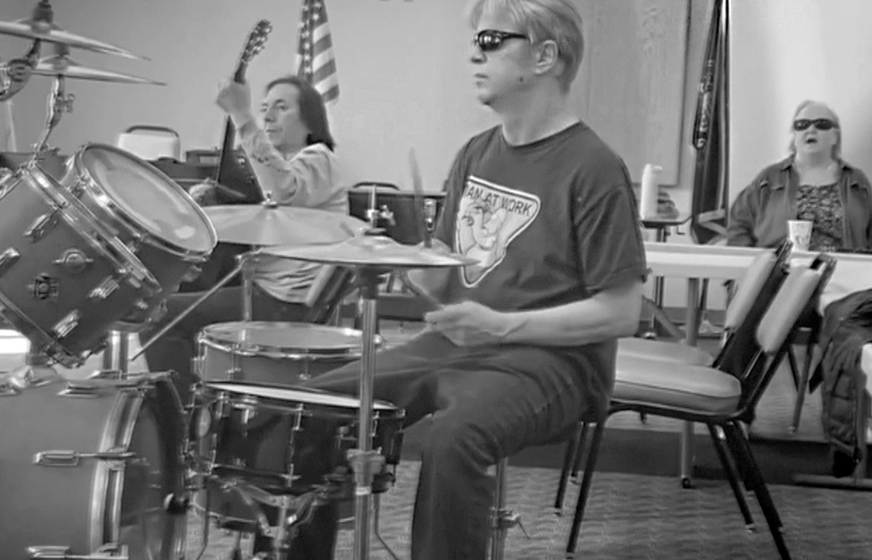The Sights for Hope client band is looking for a drummer and players of various brass instruments. Interested clients should call Rita Lang at 610.433.6018, Ext. 225.

Life Skills Education Programs

Tech Talks
  - Who Can Participate: All clients
  - Dates and Times: Thursdays, January 5, 12, 19, and 26, 2-3:30 p.m.
  - Virtual Connections: Go to SightsforHope.org/Events

Positive Coping Strategies for Depression
Facilitated by Sue Higgins.
  - Who Can Participate: All clients
  - Date and Time: Thursday, January 12, 10-11:30 a.m.
  - Location: Lehigh Valley Services Center
  - Who Can Schedule Transportation: Lehigh Valley clients

Life Skills Education Programs

Orientation and Mobility (O&M) - Part Two Rescheduled
Learn how basic orientation and mobility (O&M) techniques can help you navigate outdoors and indoors independently.
  - Who Can Participate: All clients
  - Dates and Times: Friday, January 13, 9 a.m.-12 p.m.
  - Location: Lehigh Valley Services Center
  - Who Can Schedule Transportation: All clients

iOS Device Workshop
Learn about the iPhone and iPad. Please bring a lunch or money to order.
  - Who Can Participate: All clients
  - Date and Time: Wednesday, January 18, 11 a.m.- 1 p.m.
  - Location: Lehigh Valley Services Center
  - Registration: Rita Lang at 610.433.6018, Ext. 225
  - Who Can Schedule Transportation: Not available
  - Virtual Connections: Go to SightsforHope.org/Events

Peer Support Groups

Lehigh Valley Client Group
Facilitated by James Van Horn.
  - Who Can Participate: Lehigh Valley clients
  - Date and Time: Thursday, January 5, 10-11:30 a.m.
  - Location: Lehigh Valley Services Center
  - Registration: Rita Lang at 610.433.6018, Ext. 225
  - Who Can Schedule Transportation: Lehigh Valley clients
  - Virtual Connections: Go to SightsforHope.org/Events

Monroe Client Group
Facilitated by James Van Horn.
  - Who Can Participate: Monroe clients
  - Date and Time: Monday, January 9, 10-11:30 a.m.
  - Location: Monroe Services Center
  - Registration: Lisa Metcalf at 570.992.7787, Ext. 224
  - Who Can Schedule Transportation: Monroe clients
  - Virtual Connections: Go to SightsforHope.org/Events

Peer Support Groups

Women’s Client Group
  - Who Can Participate: All female clients
  - Date and Time: Tuesday, January 10, 10-11 a.m.
  - Location: Lehigh Valley Services Center
  - Registration: Rita Lang at 610.433.6018, Ext. 225
  - Who Can Schedule Transportation: Not available
  - Virtual Connections: Go to SightsforHope.org/Events

- Descriptions Continue on Page 13

January 2023

Lehigh Valley Client Calendar
Thursday | Friday | Saturday
5  Lehigh Vly Group  10-11:30 | 6 | 7
12  Coping Strategies 10-11:30 | 13  O&M Part Two 9-12 | 14  GLVNFB Mtg 10-12
19 | 20 | 21  LVCB Mtg 10-12
26Visionaries  10:30-11:15  LV Lions 11:30-1:30 | 27 | 28

Want to Do More?
Most Monroe activities also are open to Lehigh Valley clients who can arrange their own rides.
Check out the descriptions for details.

- Weekly Services Mall Walks
January 4,
11, 18, and
25, 9-10:30

Tech Talks
January 5,
12, 19, and
26, 2-3:30

January 2023
Monroe Client Calendar

Sunday | Monday | Tuesday | Wednesday
1 | 2  Closed for Holiday | 3 | 4
8 | 9  Monroe Group 10-11:30 | 10 | 11
15 | 16  Closed for Holiday | 17 | 18
22 | 23  Swimming at Shawnee 10-12 | 24 | 25
29 | 30  Musicians 11-1 | 31NuVisions  10:30-12  Monroe Lions 1-2

January 2023

Monroe Client Calendar
Thursday | Friday | Saturday
5 | 6 | 7
12 | 13  O&M Part Two 9-12 | 14
19  Sensational Salads 10:30-12 | 20 | 21
26 | 27 | 28

Want to Do More?
Most Lehigh Valley activities also are open to Monroe clients who can arrange their own rides.
Check out the descriptions for details.

Weekly Services
Tech Talks
January 5,
12, 19, and
26, 2-3:30

January 2023
Lehigh Valley Client Calendar

Sunday | Monday | Tuesday | Wednesday
1 | 2  Closed for Holiday | 3 | 4
8 | 9 | 10Women’s  Group  10-11  Crafters 11-1 | 11
15 | 16  Closed for Holiday | 17 | 18  iOS Devices 11-1
22 | 23  Dominoes 10-11:30 | 24 | 25
29 | 30  Musicians 11-1 | 31

Activities

Mall Walks
    - Who Can Participate: All clients
    - Dates and Times: Wednesdays, January 4, 11, 18, and 25, 9-10:30 a.m.

Location: South Mall, 3300 Lehigh St., Allentown, PA
    - Who Can Schedule Transportation: Lehigh Valley clients

Crafters Corner Activity
    - Who Can Participate: All clients
    - Date and Time: Tuesday, January 10, 11 a.m.- 1 p.m.
    - Location: Lehigh Valley Services Center
    - Registration: Rita Lang at 610.433.6018, Ext. 225
    - Who Can Schedule Transportation: Not available

Activities

Sensational Salads
    - Who Can Participate: All Monroe clients
    - Date and Time: Thursday, January 19, 10:30 a.m.- 12 p.m.
    - Location: Monroe Services Center
    - Who Can Schedule Transportation: Monroe clients

Dominoes Activity
    - Who Can Participate: All clients
    - Date and Time: Monday, January 23, 10-11:30 a.m.
    - Location: Lehigh Valley Services Center
    - Registration: Rita Lang at 610.433.6018, Ext. 225
    - Who Can Schedule Transportation: Lehigh Valley clients

Activities

Swimming at Shawnee Inn and Resort
Enjoy the pool and hot tub at the Shawnee Inn and Resort.
    - Who Can Participate: All Monroe clients
    - Date and Time: Thursday, January 23, 10 a.m.-12 p.m.

Location: Shawnee Inn, 100 Shawnee Inn Drive, Shawnee on Delaware, PA
    - Who Can Schedule Transportation: Monroe clients

Visionaries Client Group Activity
January’s activity is a presentation on mindfulness. This activity is organized by the Visionaries client group but is open to all Lehigh Valley clients.
      - Who Can Participate: All Lehigh Valley clients
      - Date and Time: Thursday, January 26, 10:30- 11:15 a.m.
      - Location: Lehigh Valley Services Center
      - Who Can Schedule Transportation: Lehigh Valley clients

Activities

Musician Jam Session
    - Who Can Participate: All clients who are musicians and/or vocalists
    - Date and Time: Monday, January 30, 11 a.m.-1 p.m.
    - Location: Monroe Services Center
    - Who Can Schedule Transportation: Lehigh Valley and Monroe clients

NuVisions Client Group Activity
Learn about smart phone apps that help people with visual impairments seize their independence. This activity is organized by the NuVisions client group but is open to all Monroe clients.
    - Who Can Participate: All Monroe clients
    - Date and Time: Tuesday, January 31, 10:30 a.m.- 12 p.m.
    - Location: Monroe Services Center
    - Registration: Jennifer Pandolfo at 570.992.7787, Ext. 223
    - Who Can Schedule Transportation: Monroe clients

Meetings

LV Sights for Hope Lions Club Meeting
The Lehigh Valley Sights for Hope Lions Club will hold its Charter Celebration. All clients who live in Lehigh and Northampton counties are welcome.
    - Who Can Participate: All Lehigh Valley clients
    - Date and Time: Thursday, January 26, 11:30 a.m.- 1:30 p.m.
    - Location: Lehigh Valley Services Center
    - Additional Details: SightsforHope.org/LVLionsClub

Monroe Sights for Hope Lions Club Meeting The Monroe Sights for Hope Lions Club will hold its monthly meeting. All clients who live in Monroe County are welcome. Participants are encouraged to bring a lunch or
money to order.
    - Who Can Participate: All Monroe clients
    - Date and Time: Tuesday, January 31, 1-2 p.m.
    - Location: Monroe Services Center
    - Registration: Jennifer Pandolfo, 570.992.7787, Ext. 222
    - Who Can Schedule Transportation: Monroe clients
    - Additional Details: SightsforHope.org/MonroeLionsClub

Meetings

Greater LV Chapter - National Federation of the Blind (GLVNFB) Meeting
    - Date and Time: Saturday, January 14, 10 a.m.- 12 p.m.

Location: Denny’s Restaurant, 1871 Catasauqua Road, Allentown, PA
    - Additional Details: Call Kirk Hunger at 484.239.0741

LV Council of the Blind (LVCB) Meeting
    - Who Can Participate: LVCB members
    - Date and Time: Saturday, January 21, 10 a.m.- 12 p.m.
    - Location: Lehigh Valley Services Center
    - Additional Details: Write to LVCB1993@gmail.com

Lehigh Valley Staff Directory

Main Number 610.433.6018
Dennis Zehner, Executive Director and CEO, Ext. 241 Jennifer Pandolfo, Associate Director/Dir. of Services, Ext. 223 Deirdre Federico Snyder, Director of Advancement, Ext. 244 Nancy Cobb, Operations Manager, Ext. 242
Rita Lang, Client Activities Manager, Ext. 225 Teresa Pickett, Services Coordinator, Ext. 240
Dianne Michels, Vision Rehabilitation Therapist, Ext. 230 Stephanie Guillen, Client Caseworker, Ext. 246
Erin Hahn, Client Caseworker, Ext. 231 Erica Vibert, Client Caseworker, Ext. 227
Kim Williams, Low Vision Care Coordinator, Ext. 224 Brian Schell, Transport Coordinator, Ext. 226
Ruthie Asmus, Prevention Specialist, Ext. 248 Colleen Rountree, Prevention Specialist, Ext. 245

Monroe Staff Directory

Main Number 570.992.7787
Jennifer Pandolfo, Associate Director/Dir. of Services, Ext. 222 Teresa Pickett, Services Coordinator, Ext. 222
Yvette Quintero, Lead Client Caseworker, Ext. 221 Melinda Weston, Client Caseworker, Ext. 228 Cheryl Miller, Low Vision Care Coordinator, Ext. 229 Lisa Metcalf, Transport Coordinator, Ext. 224 Angela Hill, Prevention Specialist, Ext. 223

FREE MATTER FOR THE BLIND OR PHYSICALLY HANDICAPPED
Post Manual Part 138

Client Bulletin

This bulletin is a public service provided in part by

DESIGN | PRINT | FINISH | MAIL

This publication © 2023 Sights for Hope

